Record No: 0675
CECILIA ELIZA MARGARET BELLINGHAM SOMERVILLE (Cecil)

of 8, Clyde Road, Dublin and, subsequently, 40, Highfield Road, Rathgar, Dublin.

Eldest daughter of Bellingham Arthur Somerville (0631) by his wife Margaret Hall Clinch (0632).

Birth: 9 Oct 1880, at Francis Street, Newtownwards, Co Down.
Bapt: 15 May 1881, at St Audoen’s Dublin
Marriage: 11 Apr 1912, at Nun’s Cross Church, Killiskey, Co Wicklow, to Henry Rooke BA.
Death: 17 Aug 1973, at Bellavista Nursing Home, Stradbrook Rd, Blackrock Co Dublin
Burial: 20 Aug 1973, at Kill-of- the- Grange Cemetery, Co Dublin. (Deansgrange)

Source: Somerville Index

Notes: “Our mother had been ill for some long time. She went into the Adelaide Hospital
Christmas Day 1972 & was there for nearly five months & then she was in the Bellavista n. home where she died very suddenly and peacefully. The funeral service was at Zion Church, Rathgar, Dublin, conducted by her youngest son, Rev Wm W.W L. Rooke, the Rector The Rev R Warke & the Church assistant, The Rev.
Robin White.” Dorothy Rooke.

Cecil was the mother of four children:

Cecil Elinor Katherine Margaret( Girlie/Cecil/Margaret) bn 1 February 1913 md
19 July 1939 Major Charles Erling Bernard Catt, who d 16 February 1942, had two
daughters Cecilia Louise Somerville (Louise) bn 26 December 1940 md Alexander
Hamilton and has issue (Caspar and Cecilia) and Julia Margaret Churchill bn 23
April 1942 md Michael Pettigrew and has issue( Lucy and Timothy). Girlie d 3
January 1999

Henry Thomas Bernard Bellingham (Tommy) bn 8 July 1914 md 7 July 1945 Pia
Magdalen Virginia Dormer, who d ? and had one son Henry John Patrick Dormer
(John) bn 9 May 1946 md Helen Howard and has no issue. Tommy d 8 July 1999.

William Warburton Lloyd (Billy) bn 9 November 1916 md 30 July 1952 Lucy
Gwendolyn Rosemary Ormsby (Rose) and had one daughter and five sons, Brigid
Rosemary bn 20 May 1953 md 28 August 1976 Timothy John Michael Clesham
and has issue (Mary, Thomas and Jennifer); Patrick William bn 12 April 1955 md 7
July 1979 Alison Forsythe and has()Henry
Yeadon bn 12 April 1955 md 21 April 1990 Hazel Blair- White and has issue
( Christopher and Bevan); David Bernard bn 12 August 1956 md 31 July 1983 Sian
Evans and has issue( Cerys,Megan and Lowrie); Stephen Lloyd bn 1 May 1959 md ?
Marie Nelson and has no issue; and Peter John bn 24 August 1960 unmarried.
Billy d 15 December 1978.

Dorothy Kathleen Somerville bn 19 November 1917 d 17 May 2006

According to Gillian Gilmour, her aunt Cecil was single for 31 years, married for 31 years and a widow for 31 years.

Cecil, who had wanted to marry, in her younger days, a young man named ? Davis, an RIC constable, a
marriage of which her parents did not approve, ultimately married Henry Rooke, a friend of her father and
twenty years older than her. After his death in 1942, her unmarried daughter Dorothy devoted her life,
particularly in later years after Cecil had broken her hip and had to be literally ‘humped’ up the stairs, to
looking after her mother and enabling her to live in the manner in which she
had been brought up. Dorothy, apart from keeping a meticulous house and garden, acted as her mother’s
chauffeuse, secretary and companion, and, while Tommy and Pia were abroad, as surrogate parent to
their son John.. As is often the position in such cases, when Cecil died, Dorothy had to face the world alone
for the first time at the age of 56 and took some time to adjust to the freedom and challenges.

Cecil was a lifelong social historian and genealogist who spent most of her life building on the research into
the Somerville and related families which had occupied her father for upwards of fifty years in the second
half of the nineteenth and early years of the twentieth century. In particular, after her marriage to Henry
Rooke, she devoted her skills to exploring the history of that family and recording it for posterity. A glance
at the introduction to the Collection of the Rooke Family Papers, now housed in the National Library of
Ireland will show the depth and breadth of her interest.

Memories include her indefatigable cleaning of gravestones to read inscriptions and her statement that a
funeral is the only form of entertainment to which one does not have to be invited.

WBRBS from personal knowledge and conversation with Dorothy Rooke

The Somerville Family at Clermont about 1908

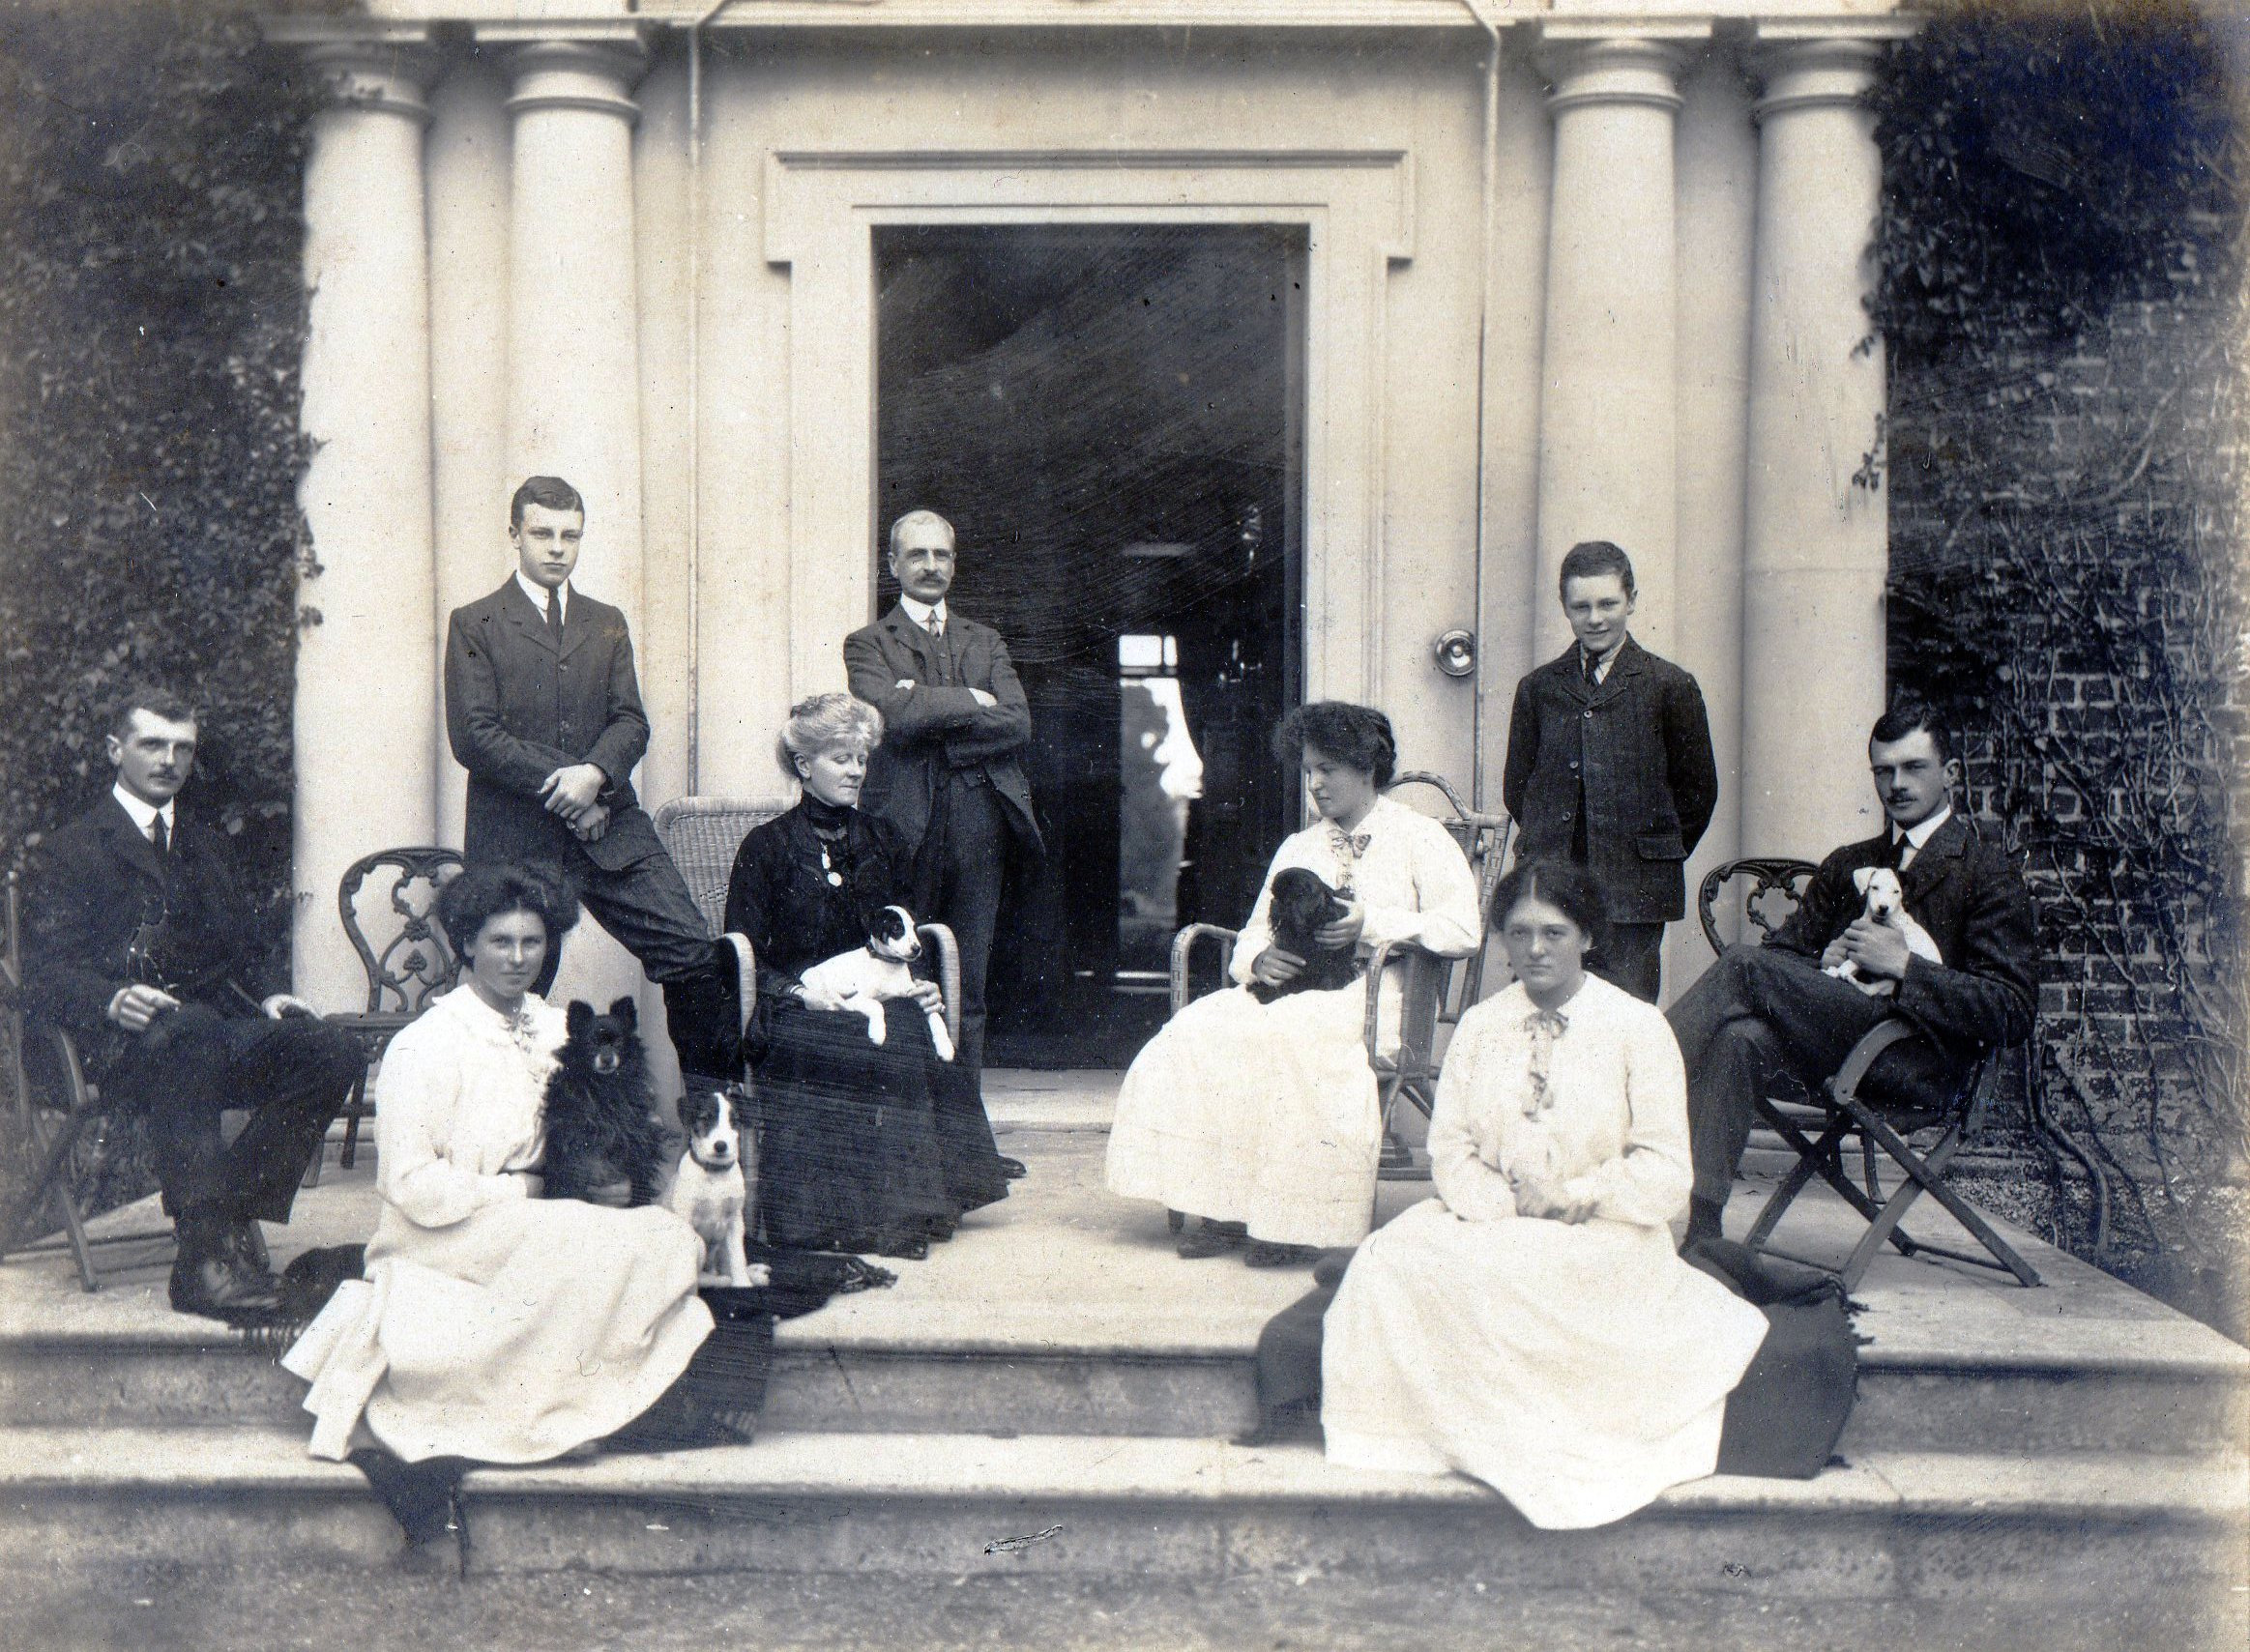
Bellingham A Somerville

Paddy Margaret H Vere Regi
Jim with Jumbo Bunt

Cecil Ede
with Billy

For the Collection of the Rooke Family Papers see: http://www.nli.ie/pdfs/mss%20lists/rooke.pdf
Cecil B. Rooke [as she always signed herself] was already a keen genealogist and it is the written records of her research into the ancestry of the Rooke family that form the main part of this collection. In the first year of her
marriage, she extracted Rooke wills and marriage licences in the Public Record Office, at the Four Courts, Dublin. These extracts were invaluable as they established the early generations of the Rooke family in Dublin and of course the originals were destroyed in 1922. Although she appears to have done considerable research on the genealogy of the Rooke family in the early years of her marriage and, no doubt, was able to establish a family tree [see Ms. 33,588 letter dated 19 Feb. 1916], it was not until the early 1950s that she set it out in a fully comprehensive manner. This was done to enable her eldest son, Colonel H.T.B.B.Rooke [Tommy Rooke], to apply to the Chief Herald of Ireland for a grant of arms [see Ms.33,597]

Despite rearing four children during the 1920s and 1930s, Cecil B. Rooke continued to take an active interest in family history, however it is evident from her papers that she had more time for research from the 1940s onwards. Her interests extended way beyond the Rooke family, as she traced back the antecedents of each female that married into the family. She relied heavily on printed works, such as the various volumns published by Sir Bernard Burke and on original sources such as parish registers, deeds and other manuscript material. She was driven by family members to churchyards all over the country where she took notes on gravestone memorials. The permanent notes [see Ms. 33,585] she compiled on so many family names are the culmination of all this research.

She was particularly interested in her own genealogy, that of the Somerville family and this is reflected in her papers. In the late 19th century her father B. A. Somerville gathered information about the family, including extracts from many Somerville wills in the Public Record Office [see Ms. 33,586 (1)] . Cecil B. Rooke
used his research (c) but she also accumulated a considerable amount of information herself about the Somervilles and their connections, such as the Bellingham, Quayle, O’Connor and many other families. It is apparent that the O’Connor family (d), with their Rolfe and Walplate connections, were one of the last families for whom she compiled permanent notes, as were the Chambalyne family, Irish connections of her
daughter in law Pia Dormer. The permanent notes for these families were ready for filing when the collection was deposited in the National Library. Although Cecil B.Rooke continued her genealogical researches well into the 1960s when she was in her eighties, the registration of the Rooke and Somerville pedigrees in 1955 and the
supporting notes she prepared to prove these pedigrees [see Ms. 33,592, and microfilm N.L.I. p.3236] were the main achievements in her life long interest.

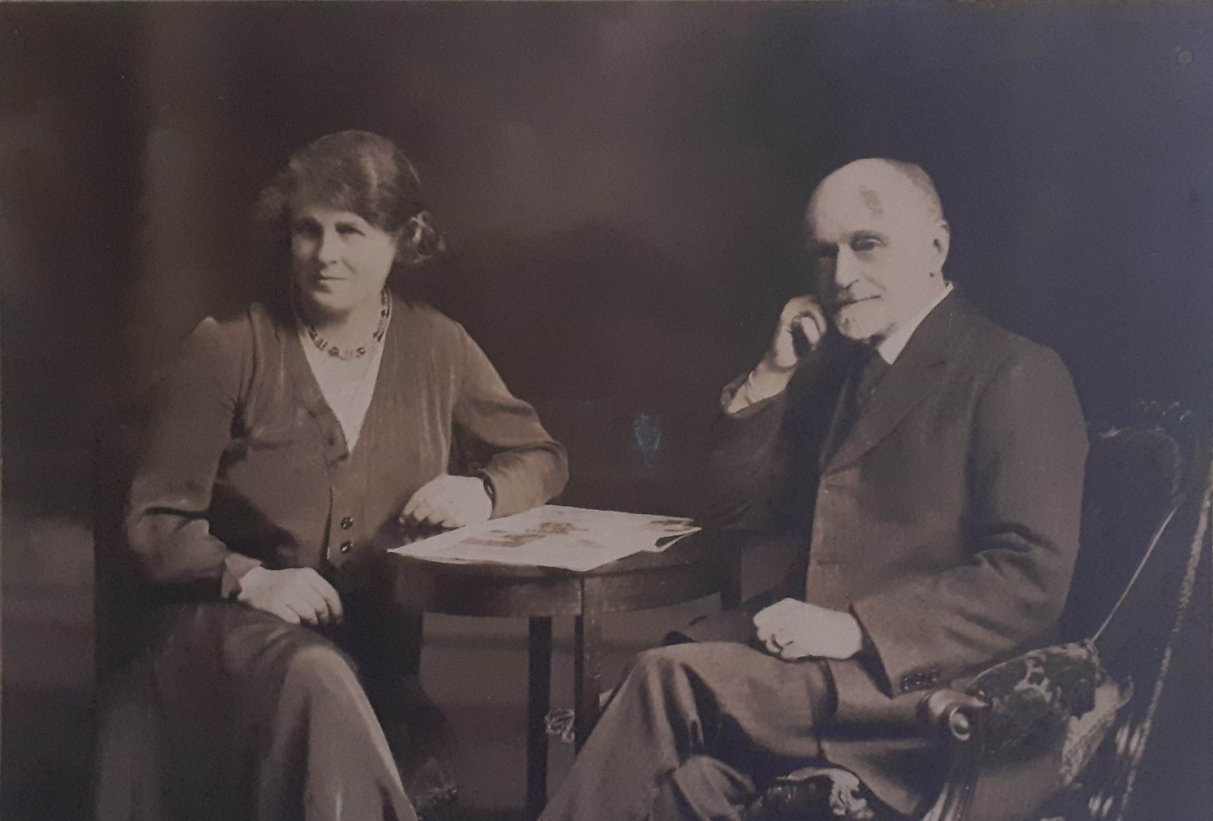

Henry Rooke and Cecil E M B Rooke
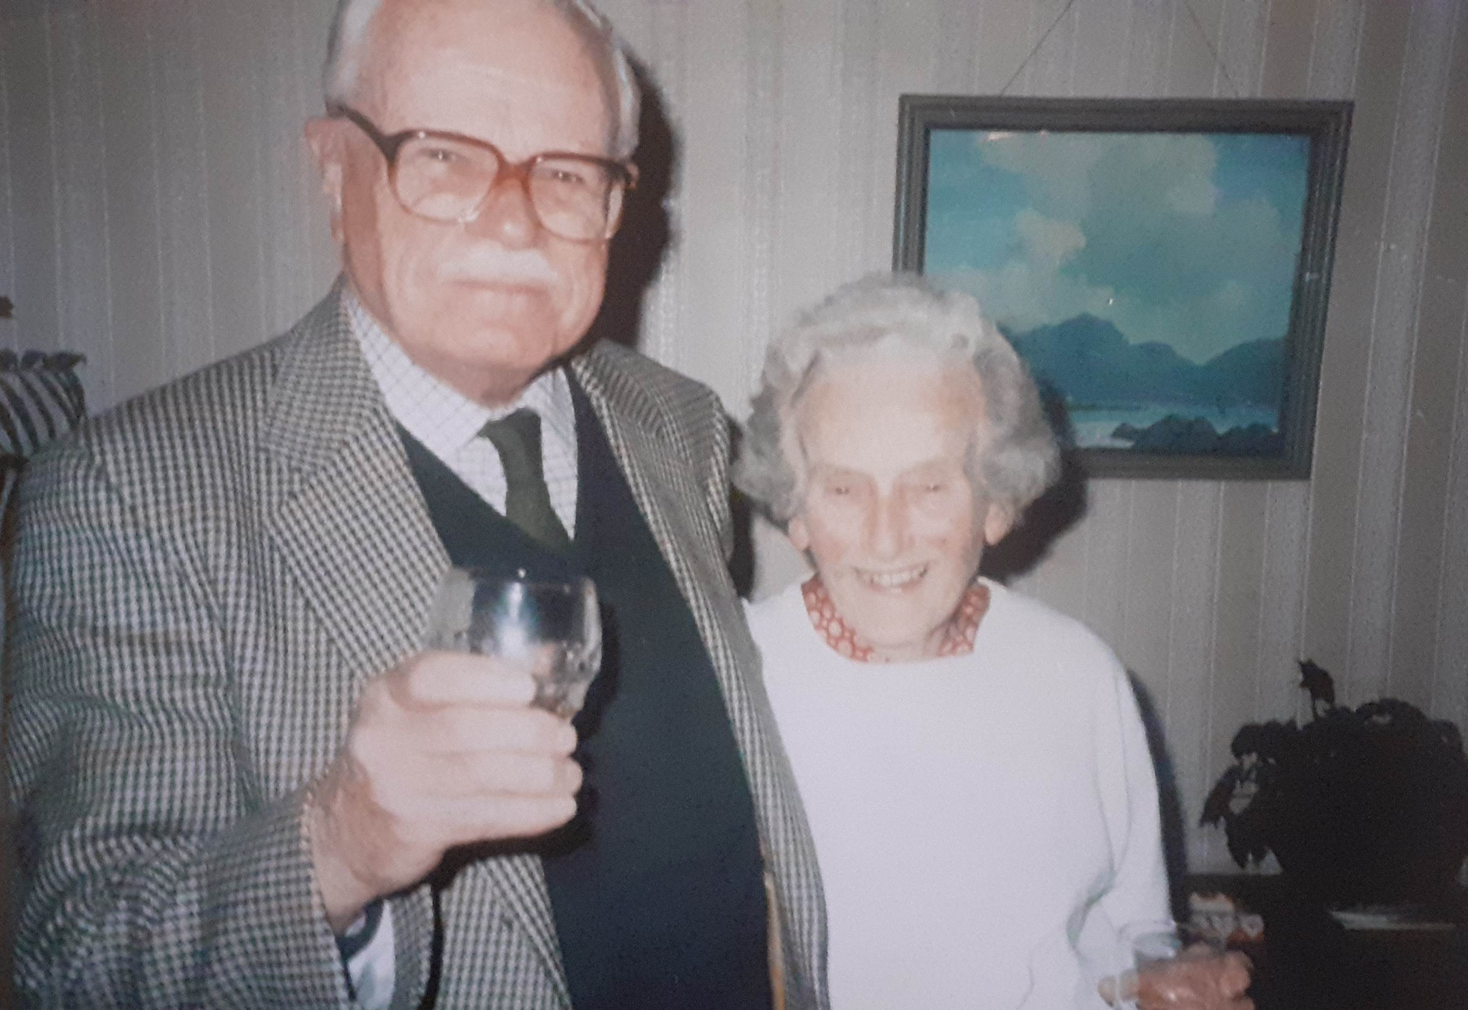

Henry T B B Rooke ‘Tommy’ and Dorothy Rooke taken on Dorothy’s 80th birthday at Dorothy’s house.

